CS504 Software Engineering
HOS09A – Microservices

Developed by Ajay Naik on 05/21/2023
Reviewed by Clark Ngo on 04/02/2026
Reviewed by Sumit K C on 06/16/2026

School of Technology & Computing (STC)
City University of Seattle (CityU)

Overview
In this HOS, we will learn about creating and Deploying a Function on the Azure platform.

Before You Start
- Screenshots may be different from your environment.
- The directory path shown in the screenshots may differ from yours.
- The steps might have subtle discrepancies. Please use your best judgment while completing each step in this cookbook-style tutorial.
- Some steps may not be explained in detail. If you are not sure what to do:
- Consult the resources from the course.
- If you cannot solve the problem after a few tries (usually 15 -30 minutes), ask a TA for help.

Learning Outcomes
- Section 1: Azure Function
- Section 2: Pushing Your Work to GitHub

Resources
- Azure Functions documentation | Microsoft Learn
- MS’s Copilot, OpenAI’s ChatGPT, Google’s Gemini, and Grammrly.com are used to develop this HOS.

Upload the following to your GitHub Repository generated from the GitHub

- Upload the screenshot of your ‘01 daysbetween.png’ as ‘01_daysbetween_firstname_lastname.png’ by using your first and last name.

Azure Function
Azure Functions are a Serverless Compute service offered by Microsoft Azure that enables developers to run event-driven code without having to explicitly provision or manage infrastructure.

- The core idea behind serverless computing is that you do not have to provision, manage, or scale servers yourself. Azure handles all of that, so you can focus solely on writing your application logic.
- Azure Functions are suitable for a wide variety of scenarios, including building serverless APIs by Creating RESTful endpoints for web and mobile applications.
- Azure Functions are a powerful and cost-effective way to build and deploy serverless microservices, allowing you to focus on business logic and leverage Azure's automatic scaling and infrastructure management capabilities. They fit perfectly into an event-driven microservice architecture.

Section 1: Azure Function

Configure your environment
Before you begin, make sure that you have the following requirements in place:
- An Azure account with an active subscription. Create an account for free.
- A Python version that is supported by Azure Functions. For more information, see How to install Python.
- Visual Studio Code on one of the supported platforms.
- The Python extension for Visual Studio Code.
- The Azure Functions extension for Visual Studio Code, version 1.8.1 or later.
- The Azurite V3 extension local storage emulator. While you can also use an actual Azure storage account, this article assumes you are using the Azurite emulator.

- Create a folder named “azure-functions.” And then, open your VS Code locally. For example,

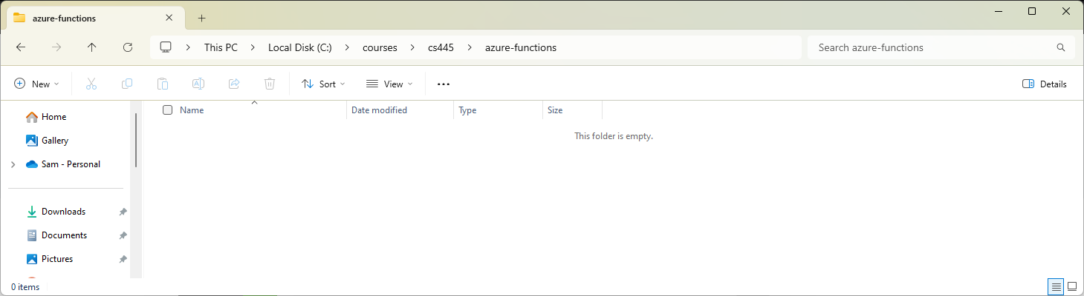

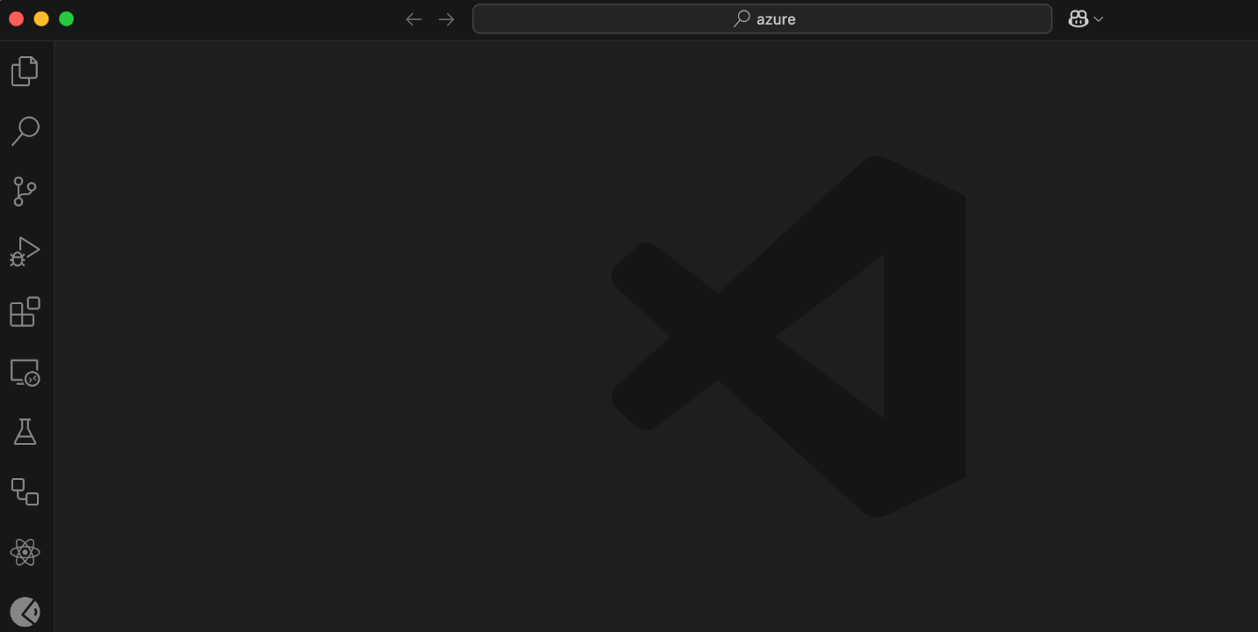

- Install the following extensions, “Azure Functions” and “Azurite”.

- Azure Functions - An Azure Functions extension for Visual Studio Code.

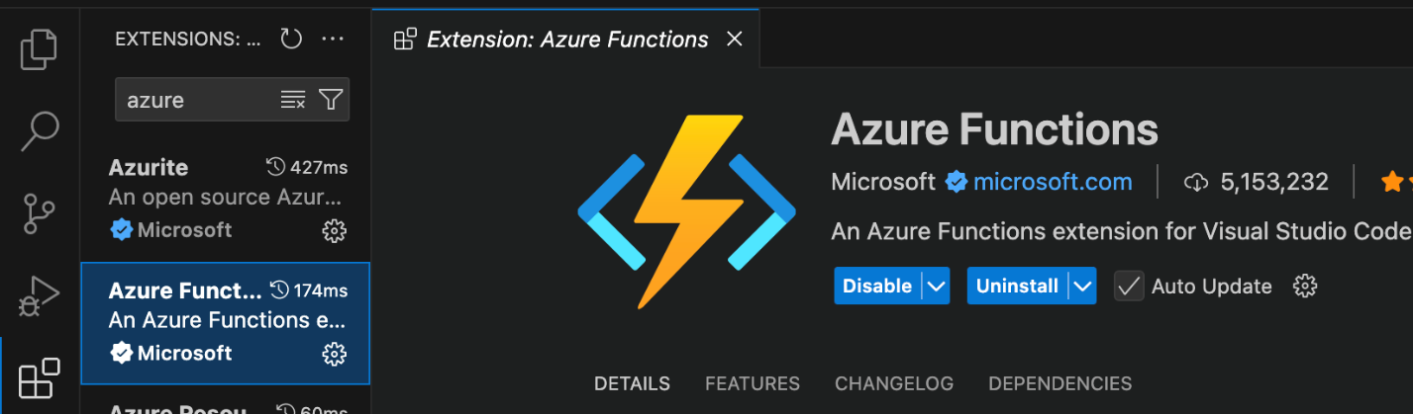

- Azurite - An open-source Azure Storage API compatible server.

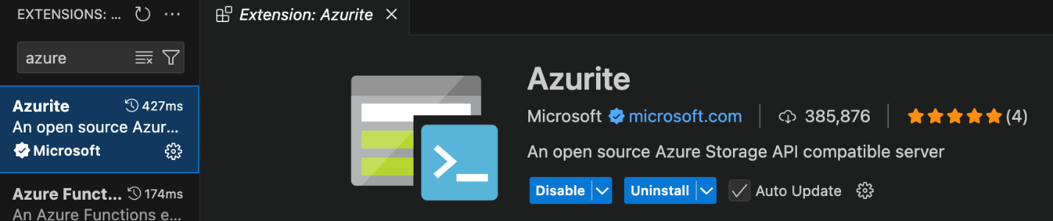

Note: Dev Containers might be needed when prompted. You may skip this for now.

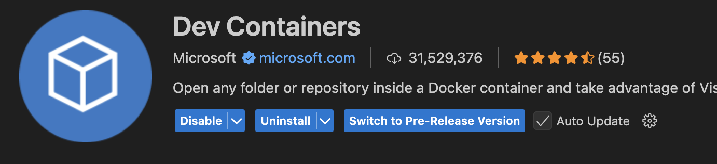

- Create your local project

- In Visual Studio Code, press F1 to open the command palette and search for and run the command “Azure Functions: Create New Project....”.

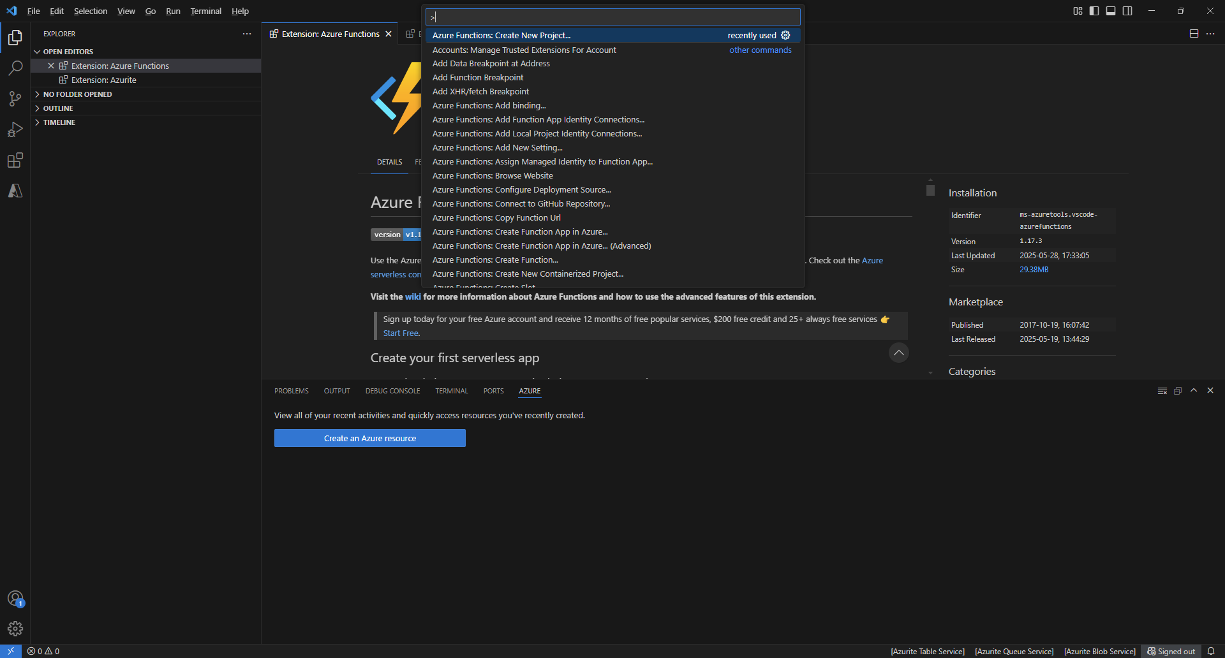

- Choose the directory location for your project workspace and choose Select. You should either create a new folder or choose an empty folder for the project's workspace. Do not choose a project folder that is already part of a workspace.
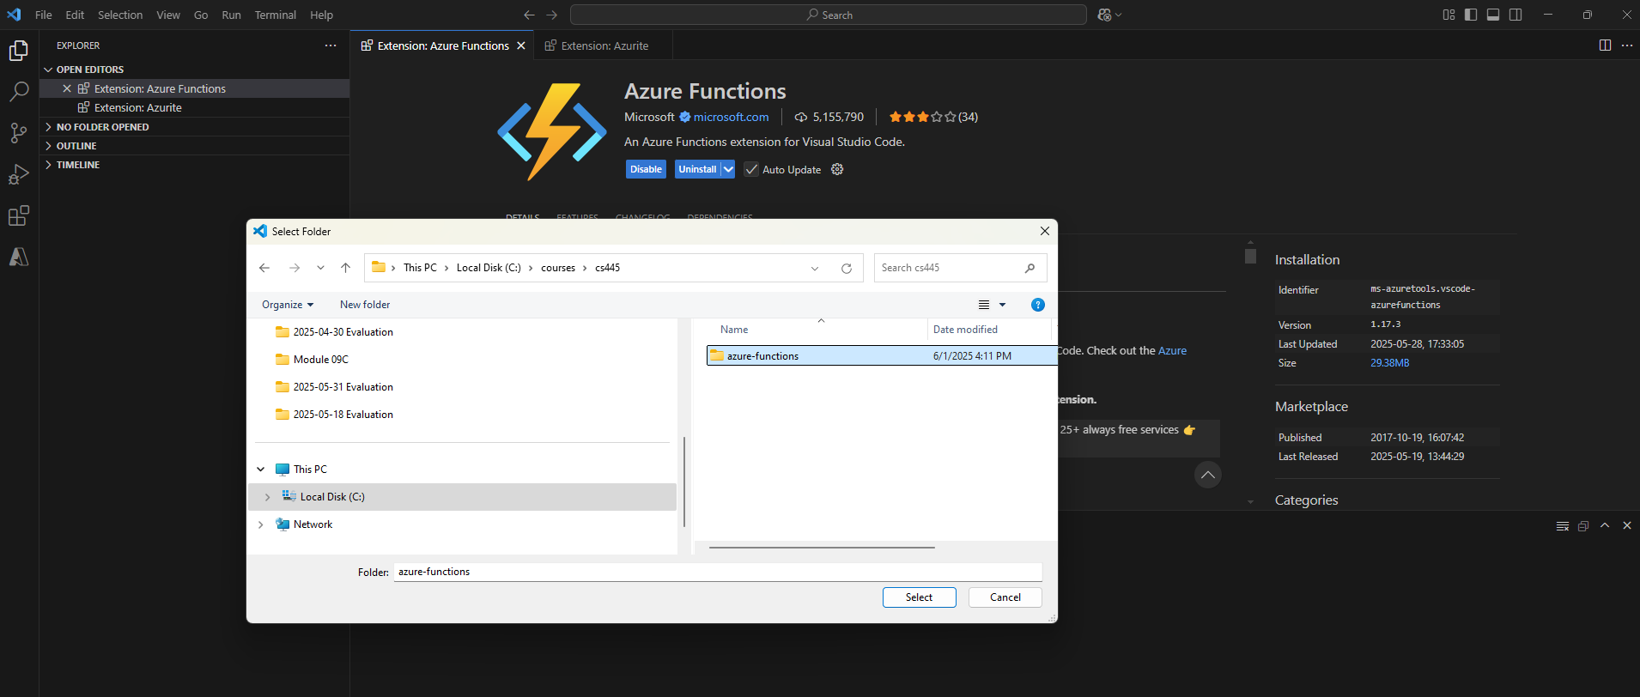

- Provide the following information at the prompts. Follow the given screenshots below.

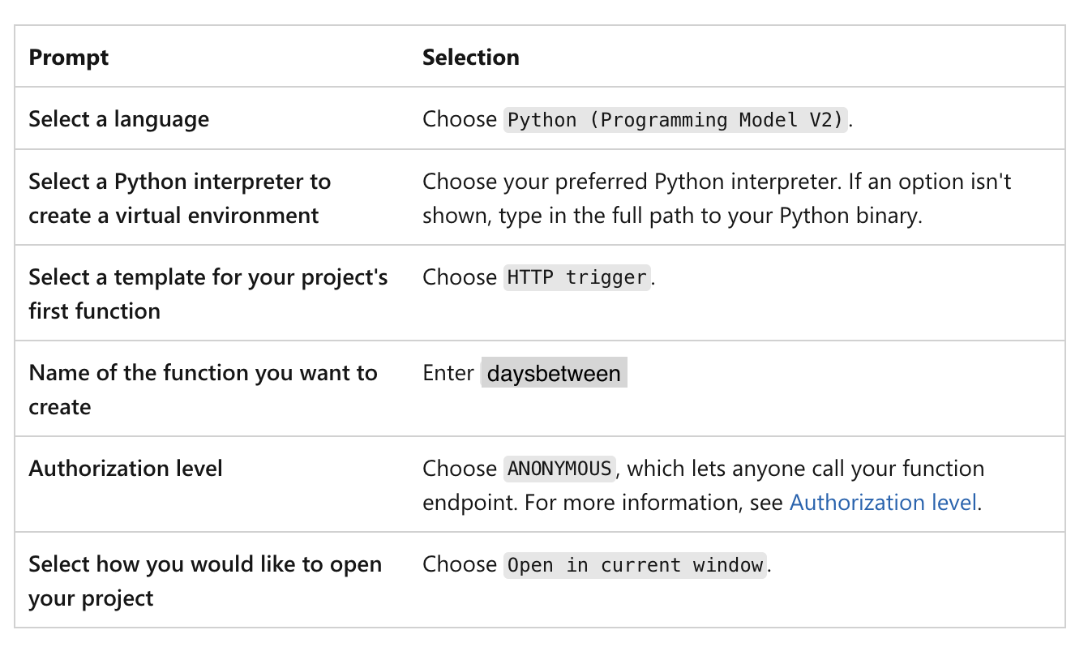

Example:

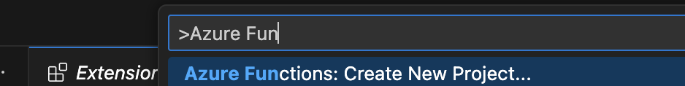

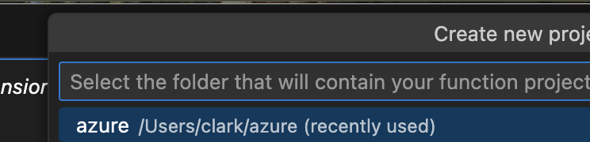

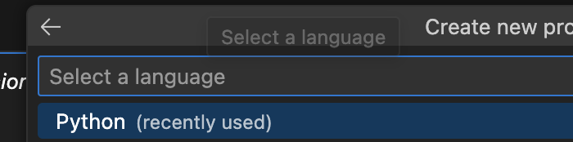

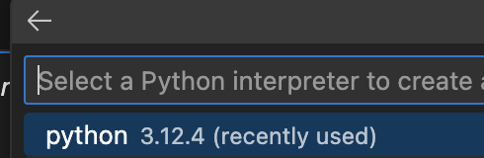

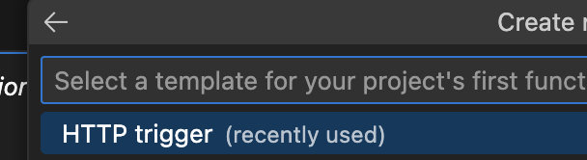

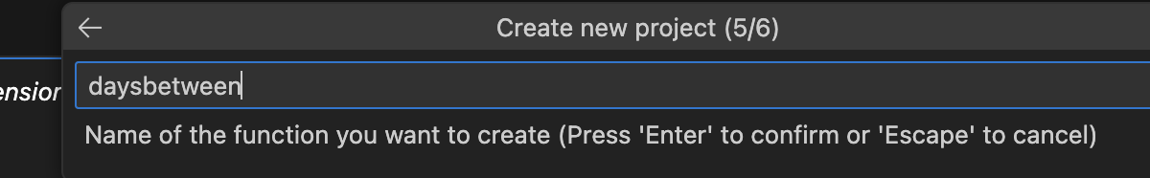

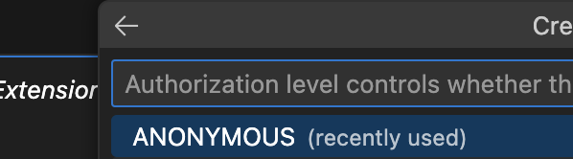

- In the local.settings.json file, update the AzureWebJobsStorage setting as in the following example:

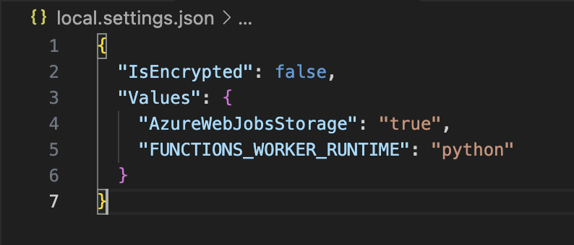

- Install dependencies. In your terminal:

- MacOS:
>> brew tap azure/functions
>> brew install azure-functions-core-tools@4
If you do not have brew: install it here: https://brew.sh/

- On Windows:
>> npm install -g azure-functions-core-tools@4 --unsafe-perm true
It is used to globally install version 4 of the Azure Functions Core Tools using npm (Node Package Manager).

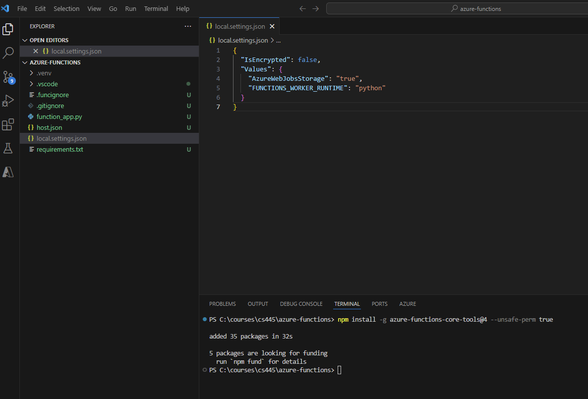
- Change the function_app.py file.

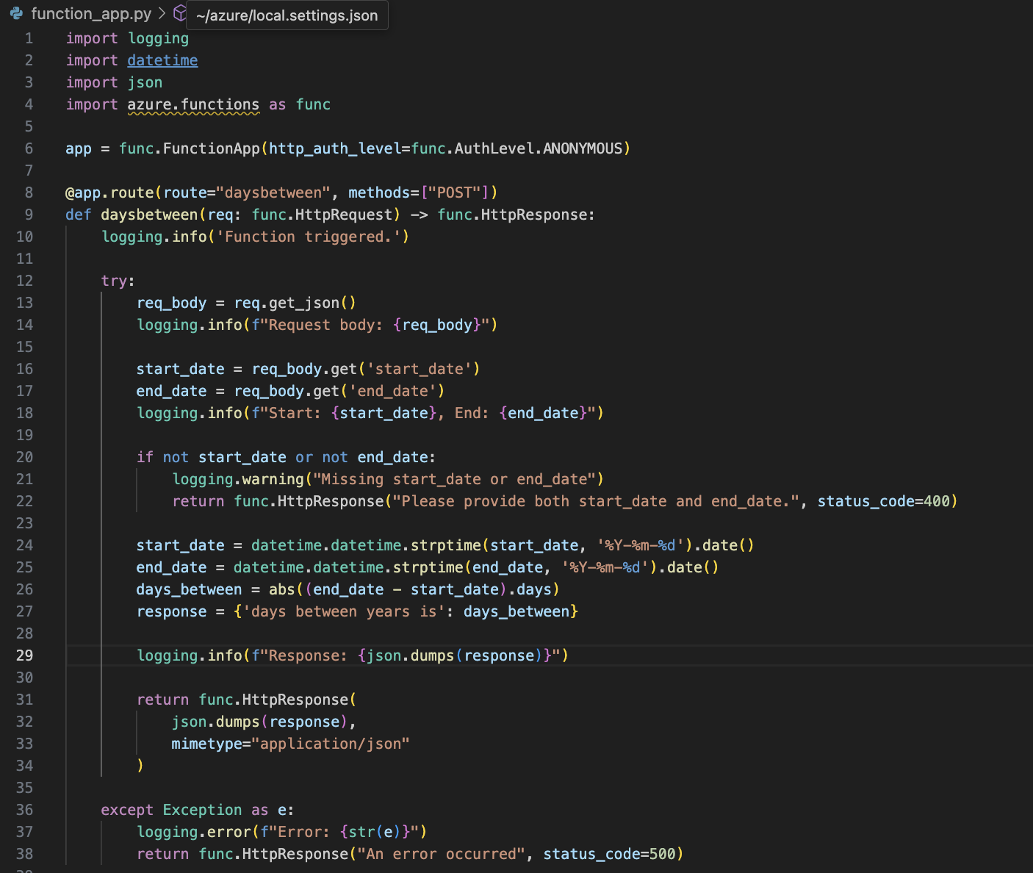

Function Overview
- Trigger: HTTP POST requests the /daysbetween route.
- Input: JSON body with start_date and end_date in YYYY-MM-DD format.
- Output: JSON response with the number of days between the two dates.

Test your code:

- In Visual Studio Code, press F1 to open the command palette. In the command palette, search for and select Azurite: Start.

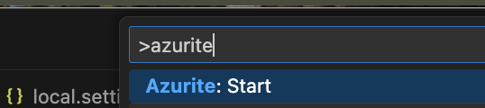

- To start the function locally, press F5 or the Run and Debug icon in the left-hand side Activity bar. The Terminal panel displays the Output from Core Tools. Your app starts in the Terminal panel. You can see the URL endpoint of your HTTP-triggered function running locally.

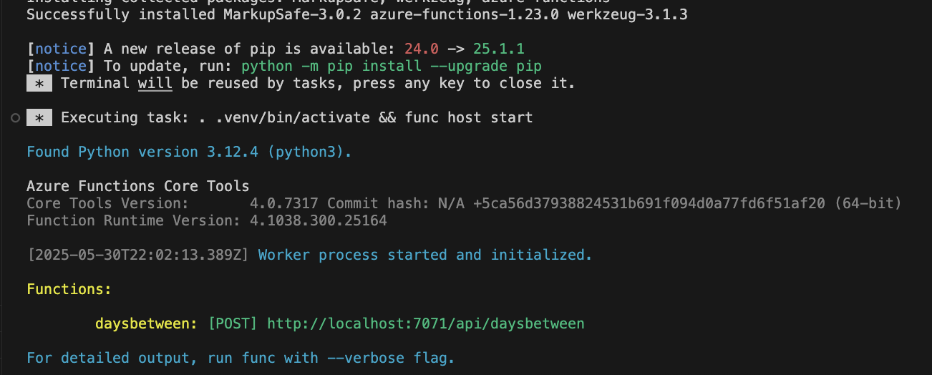
- Test in Azure.

- Click Azure Icon.
When prompted to sign it, please do so. It will redirect Sign-In into your Azure account, Sign-in, and return to Visual Studio Code.

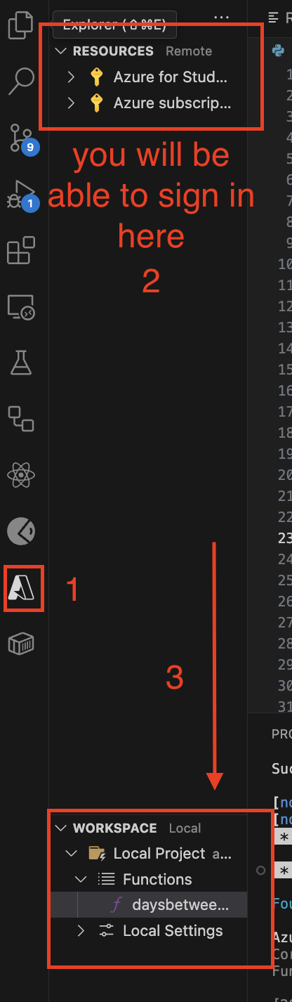

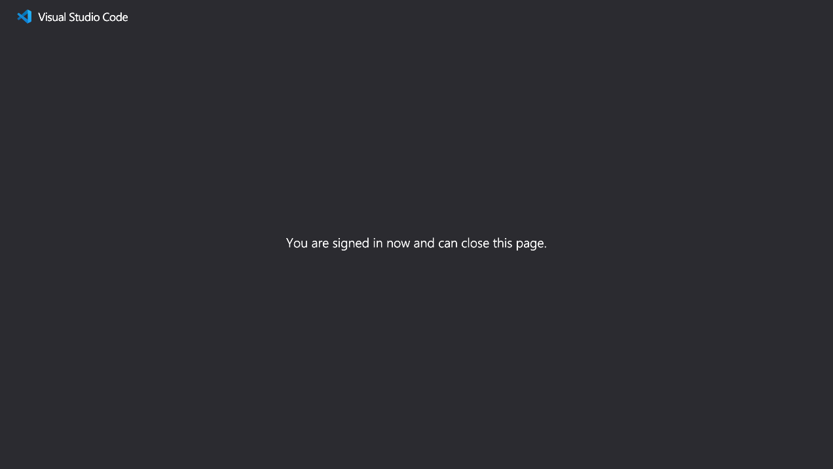

- Click Local Project in the Workspace. Click Functions. Right-click daysbetween. Click Execute Function Now...

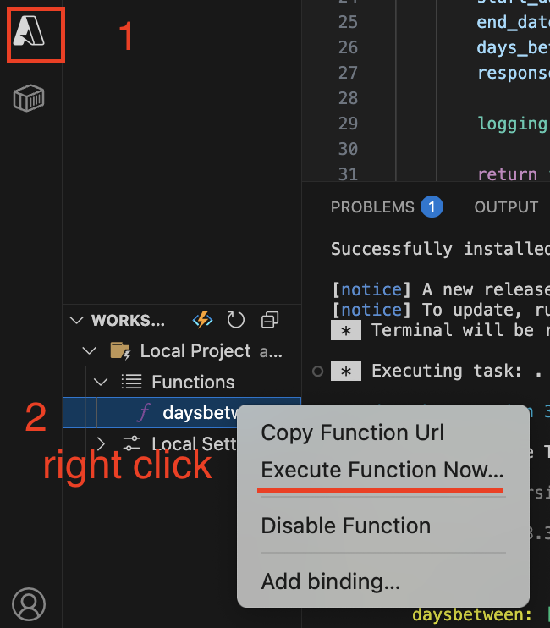

- Add start date and end date json body:
{“start_date”: “2020-01-01”, “end_date”: “2022-01-01”}

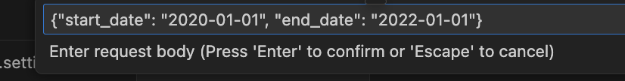

- Check the output and it should be 731 days difference

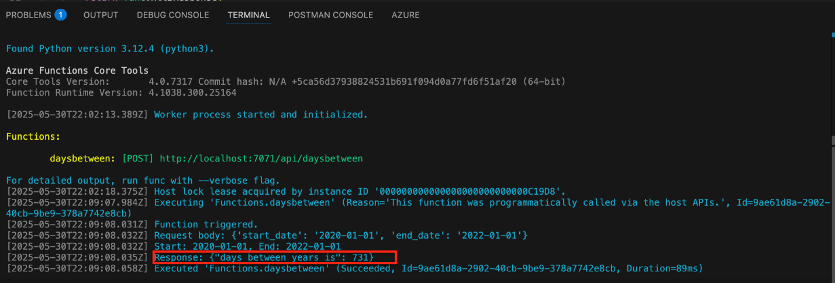

Take a screenshot here.

Section 2: Pushing Your Work to GitHub

How to submit your work in GitHub

